**JAVA DAY 5 WEEK 1 IDENTIFIERS**

**Java Identifiers**

Identifiers are the names of variables, methods, classes, packages and interfaces. Unlike literals they are not the things themselves, just ways of referring to them. In the HelloWorld program, **HelloWorld**,  **args**, **main** and**println** are identifiers.

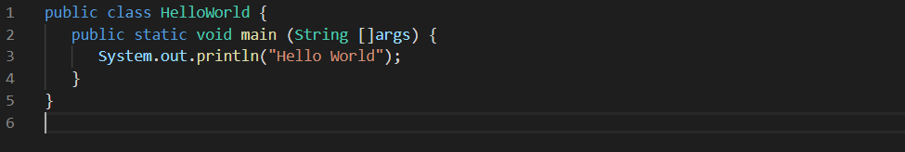

Identifiers must be composed of letters, numbers, the underscore _ and the dollar sign $. Identifiers may only begin with a letter, the underscore or a dollar sign.

Java uses CamelCase as a practice for writing names of Identifiers (methods, variables, classes, packages and constants)

**Camel case consists** of compound words or phrases such that each word or abbreviation begins with a capital letter or first word with a lowercase letter, rest all with capital.

**Java Modifiers**

Modifiers are keywords that you add to those Identifiers to change their meanings. Java language has a wide variety of modifiers, including the following −

* Java Access Modifiers
* Non-Access Modifiers

To use a modifier, you include its keyword in the definition of a class, method, or variable. The modifier precedes the rest of the statement, as in the following example, the words in bold blue are modifiers.

